Docker Task

Task Description:

Install docker on EC2 and explore the docker commands (docker images, containers, volumes, network)

Step 1: Install docker on EC2

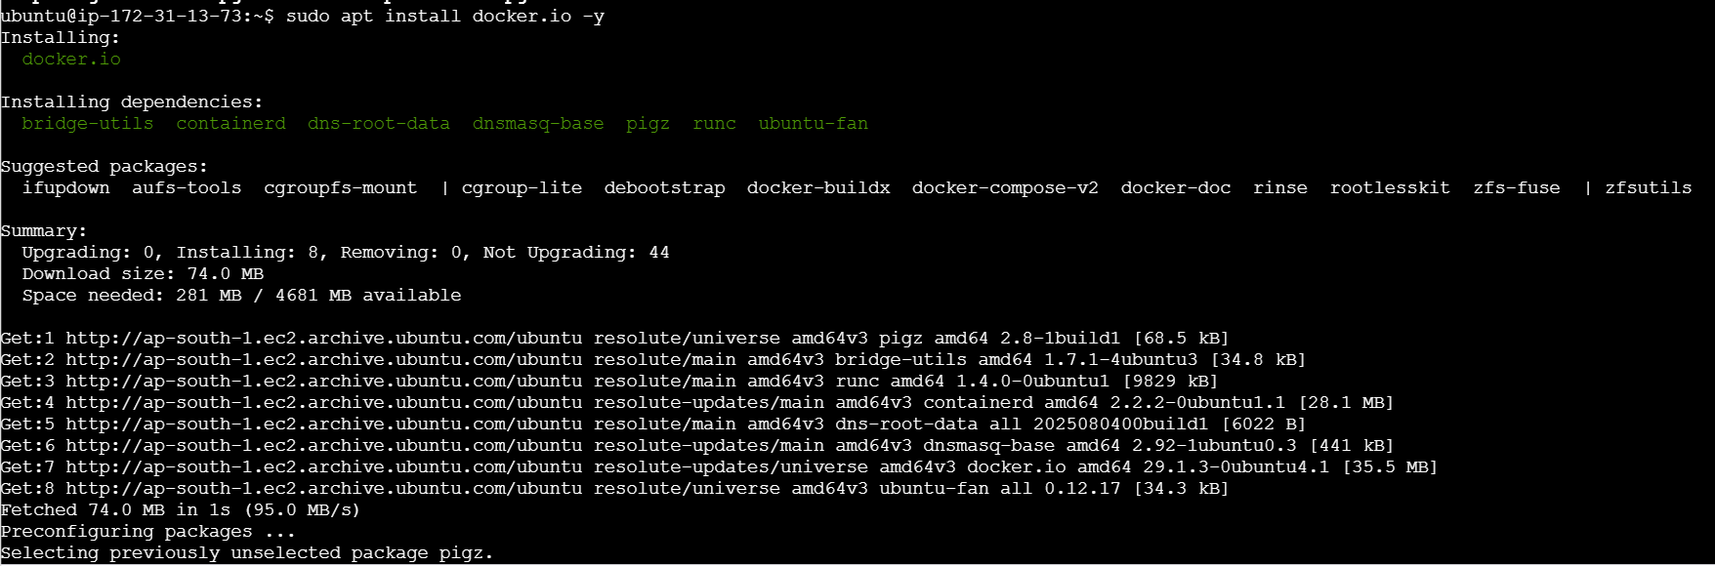
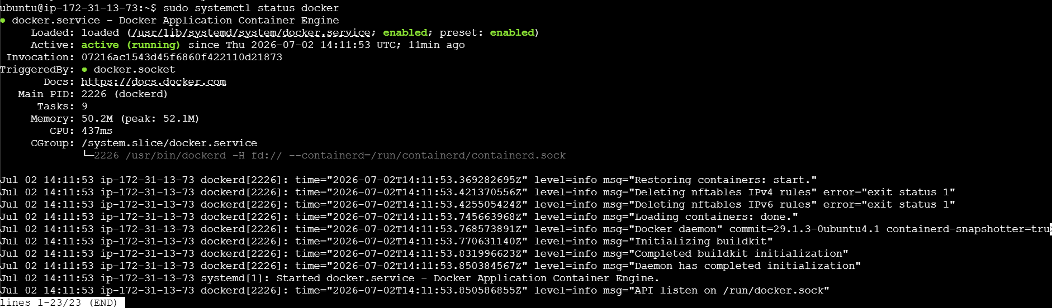
Step 2: Execute docker commands
